The PowerShell Database Quest: Uncover the Lost Relics

Chapter 1: The Connection Crystal
Task 1: Obtaining the Connection Crystal

first challenge is to acquire the Connection Crystal— a powerful artifact that allows you to connect to the central SQL Server. Use PowerShell to create a connection to the database and prove your worthiness.

Powershell:

# Task 1: Connecting to the Database Server

#TO DO: Download and Install the”
“ https://go.microsoft.com/fwlink/p/?linkid=2215158&clcid=0x409&culture=en-us&country=us”
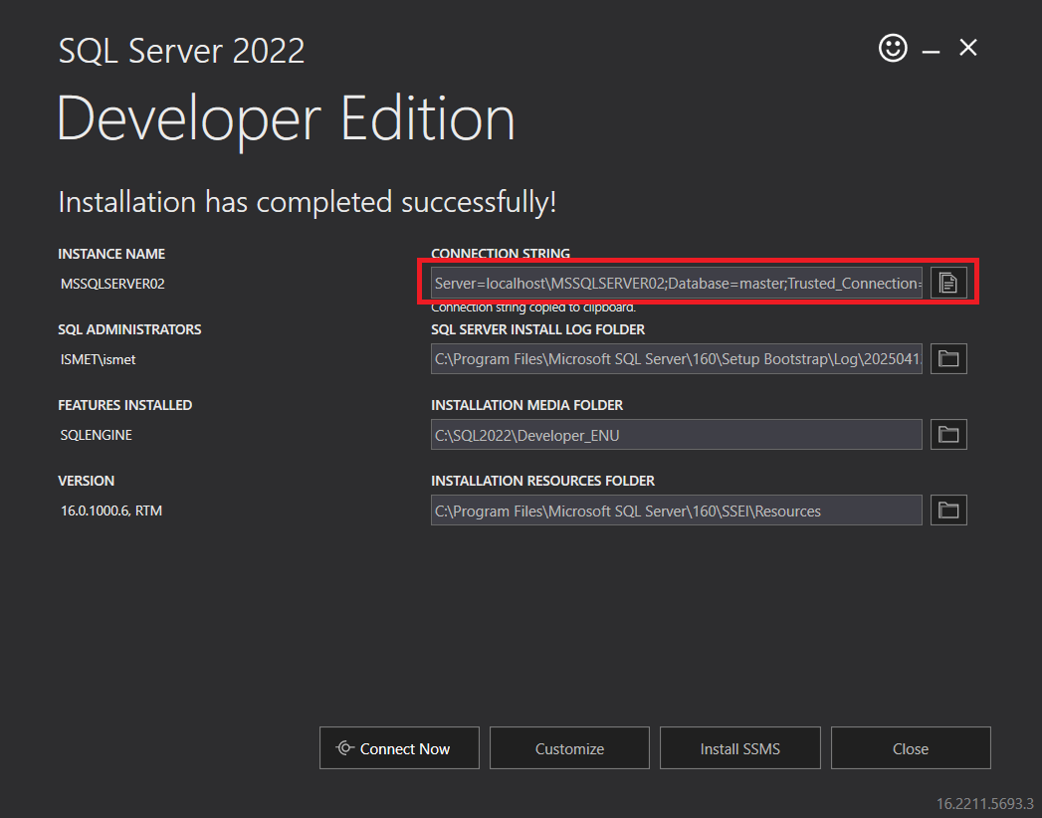

Copy the link and open the window. Don’t click connect now/ install SSMS

#The path to the installed file maybe different for different machines

Task-1 —-- Connection
# Task 1:

$connectionString = "Server=localhost;Database=master;Trusted_Connection=True;"

$connection = New-Object System.Data.SqlClient.SqlConnection
$connection.ConnectionString = $connectionString

try {
$connection.Open()
Write-Host "Connection to the SQL Server established successfully!" -ForegroundColor Green
}
catch {
Write-Host " Connection failed: $_" -ForegroundColor Red
}
finally {
if ($connection.State -eq 'Open') {
$connection.Close()
Write-Host "Connection closed." -ForegroundColor Yellow
}
}

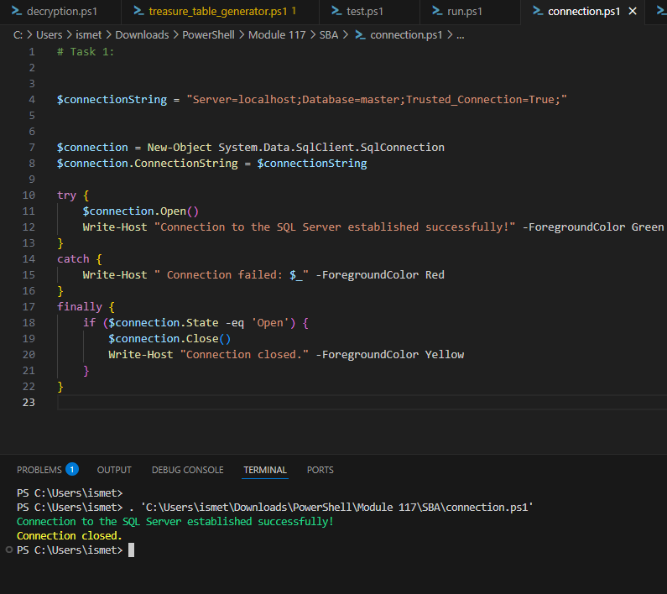

Chapter 2: The Scroll of Queries
Task 2: Decrypting the Scroll of Queries
The Scroll of Queries holds mysterious SQL commands that can unlock the database's secrets. Create a PowerShell script to query data from the "Adventurers" table and reveal the names of those who dared to embark on this quest.

Powershell:# Example PowerShell script to retrieve adventurer names from the database
# Chapter 2: The Scroll of Queries
# Task 2: Decrypting the Scroll of Queries

# Create connection string
$connectionString = "Server=localhost;Database=master;Trusted_Connection=True;"

# Create connection
$connection = New-Object System.Data.SqlClient.SqlConnection
$connection.ConnectionString = $connectionString

# SQL to create Adventurers table
$createAdventurersTable = @"
IF OBJECT_ID('Adventurers', 'U') IS NOT NULL DROP TABLE Adventurers;
CREATE TABLE Adventurers (
Id INT IDENTITY(1,1) PRIMARY KEY,
Name NVARCHAR(100) NOT NULL
);
"@

# SQL to insert brave adventurers
$adventurersValues = @"
INSERT INTO Adventurers (Name) VALUES
('Baron von Ticklebottom'),
('Sir Reginald Pantsalot'),
('Gloria Thunderbritches'),
('Dirk Daringly Unprepared'),
('Lady Wigglesworth of Oddshire'),
('Bongo the Mildly Concerned'),
('Professor McSnickerdoodle'),
('Slippery Pete McGuffin'),
('Ambrosia Laughingstock'),
('Captain Clumsybeard'),
('Flimsy McTavish'),
('Duchess Quirk von Bellyflop'),
('Snickerdoodle the Unwashed'),
('Lord Bumbleberry'),
('Gertrude Oops O Malley'),
('Blunderella Stumbletoe'),
('Sir Jangles-a-Lot'),
('Dame Noodlearms'),
('Binky the Bewildered'),
('Count Flapdoodle');
"@

try {
$connection.Open()

# Create and populate the table
$command = $connection.CreateCommand()
$command.CommandText = $createAdventurersTable
$command.ExecuteNonQuery()

$command.CommandText = $adventurersValues
$rowsInserted = $command.ExecuteNonQuery()
Write-Host "Inserted $rowsInserted brave adventurers into the Adventurers table." -ForegroundColor Green

# Query and reveal the adventurers
$command.CommandText = "SELECT Name FROM Adventurers"
$adapter = New-Object System.Data.SqlClient.SqlDataAdapter $command
$dataset = New-Object System.Data.DataSet
$adapter.Fill($dataset) | Out-Null
Write-Host "`n⚔️ Those who dared to embark on the quest:" -ForegroundColor Cyan
$dataset.Tables[0] | Format-Table -AutoSize

}
catch {
Write-Host "Error: $_" -ForegroundColor Red
}
finally {
if ($connection.State -eq 'Open') {
$connection.Close()
}
}

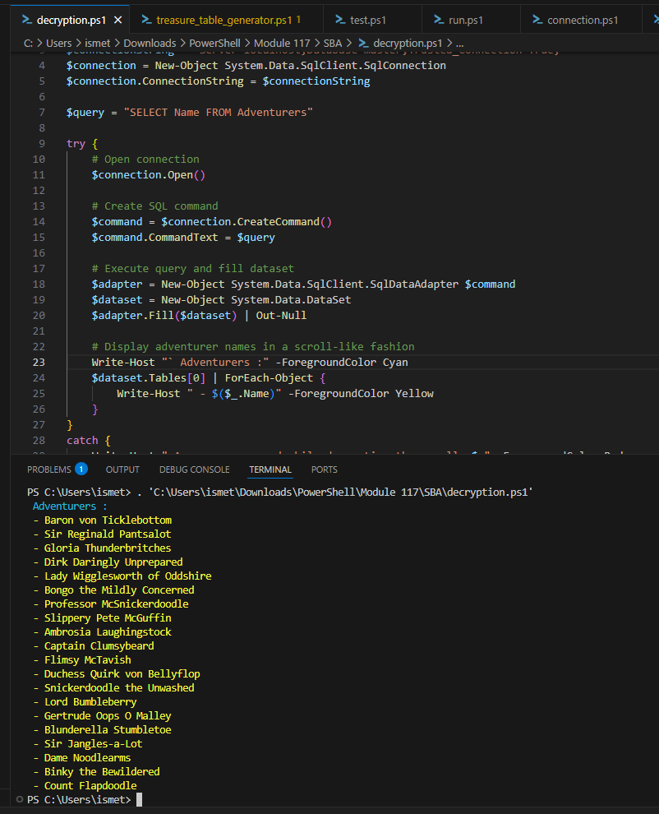

Chapter 3: The Relic of Insertion
Task 3: Unearthing the Relic of Insertion
need to insert your name into the "Adventurers" table as a brave quest-taker. Use PowerShell to insert your adventurer name into the database.

Powershell: Asked to the Chat GTP
# Example PowerShell script to insert an adventurer into the database
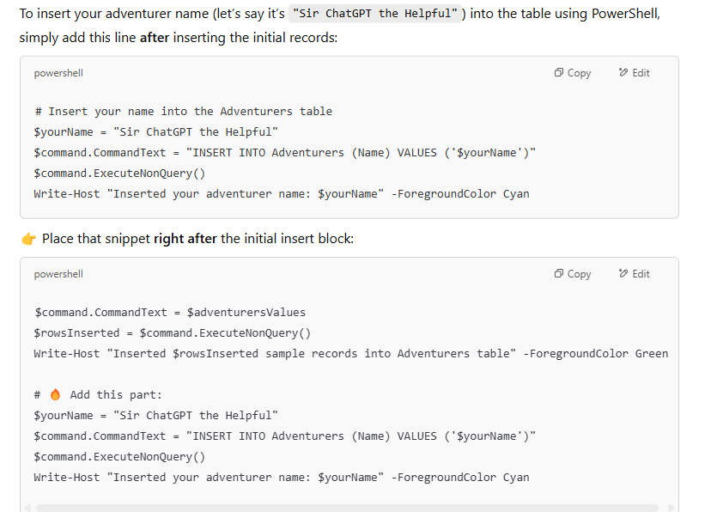
Full Code :

# Unearthing the Relic of Insertion
# In your journey, you will need to insert your name into the "Adventurers" table as a brave quest-taker.
# Use PowerShell to insert your adventurer name into the database.

# STEP 1: Create connection string to the database
$connectionString = "Server=localhost;Database=master;Trusted_Connection=True;"

# STEP 2: Initialize SQL connection object
$connection = New-Object System.Data.SqlClient.SqlConnection
$connection.ConnectionString = $connectionString

# STEP 3: SQL to create the Adventurers table
# — This is the Adventurers table definition —
$createAdventurersTable = "
DROP TABLE IF EXISTS Adventurers;
CREATE TABLE Adventurers (
Id INT IDENTITY(1,1) PRIMARY KEY,
Name NVARCHAR(100) NOT NULL
);
"

# STEP 4: Define the initial insert block
# — These are the initial legendary adventurers —
$adventurersValues = "
INSERT INTO Adventurers (Name) VALUES
('Baron von Ticklebottom'),
('Sir Reginald Pantsalot'),
('Gloria Thunderbritches'),
('Dirk Daringly Unprepared'),
('Lady Wigglesworth of Oddshire'),
('Bongo the Mildly Concerned'),
('Professor McSnickerdoodle'),
('Slippery Pete McGuffin'),
('Ambrosia Laughingstock'),
('Captain Clumsybeard'),
('Flimsy McTavish'),
('Duchess Quirk von Bellyflop'),
('Snickerdoodle the Unwashed'),
('Lord Bumbleberry'),
('Gertrude Oops O Malley'),
('Blunderella Stumbletoe'),
('Sir Jangles-a-Lot'),
('Dame Noodlearms'),
('Binky the Bewildered'),
('Count Flapdoodle');
"

try {
# STEP 5: Open connection
$connection.Open()

# STEP 6: Execute table creation
$command = $connection.CreateCommand()
$command.CommandText = $createAdventurersTable
$command.ExecuteNonQuery()

# STEP 7: Execute the initial insert block (legendary heroes)
$command.CommandText = $adventurersValues
$rowsInserted = $command.ExecuteNonQuery()
Write-Host "Inserted $rowsInserted sample records into Adventurers table" -ForegroundColor Green

# STEP 8: Insert your adventurer name — the Relic of Insertion 🗡️
$yourName = "Sir ChatGPT the Helpful" # <== Change this to your own legendary name!
$command.CommandText = "INSERT INTO Adventurers (Name) VALUES ('$yourName')"
$command.ExecuteNonQuery()
Write-Host "Inserted your adventurer name: $yourName" -ForegroundColor Cyan

# STEP 9: Display the contents of the Adventurers table
$command.CommandText = "SELECT * FROM Adventurers"
$adapter = New-Object System.Data.SqlClient.SqlDataAdapter $command
$dataset = New-Object System.Data.DataSet
$adapter.Fill($dataset) | Out-Null
$dataset.Tables[0] | Format-Table -AutoSize
}
catch {
# STEP 10: Handle any errors
Write-Host "Error: $_" -ForegroundColor Red
}
finally {
# STEP 11: Close the connection if it's still open
if ($connection.State -eq 'Open') {
$connection.Close()
}
}

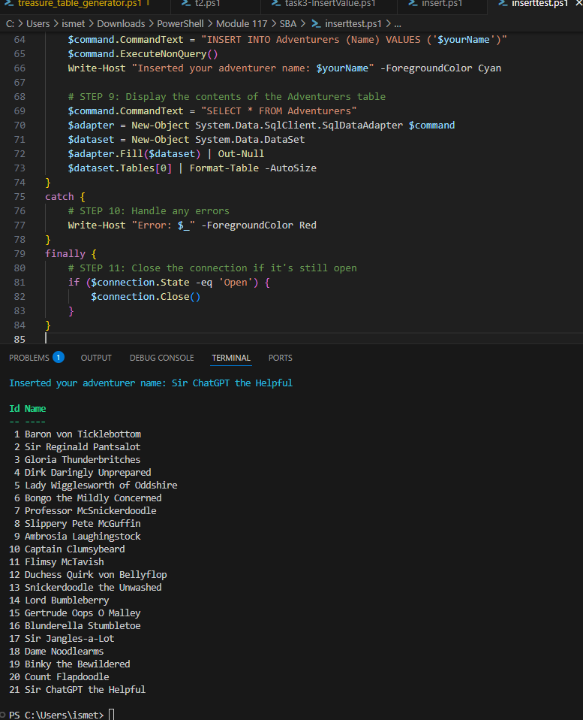

Chapter 4: The Lost Artifacts
Task 4: Rescuing the Lost Artifacts
Legend has it that valuable artifacts were lost in the "LostArtifacts" table. Retrieve and display these lost relics to gain insight into their mystical properties.

Powershell
# Example PowerShell script to retrieve lost artifacts from the database

# Create connection string
$connectionString = "Server=localhost;Database=master;Trusted_Connection=True;"

# Create connection
$connection = New-Object System.Data.SqlClient.SqlConnection
$connection.ConnectionString = $connectionString

$createLostArtifactsTable = "
DROP TABLE IF EXISTS LostArtifacts
CREATE TABLE LostArtifacts (
ArtifactId INT IDENTITY(1,1) PRIMARY KEY,
ArtifactName NVARCHAR(100) NOT NULL,
ArtifactPower NVARCHAR(100) NOT NULL,
ArtifactStatus NVARCHAR(100) CHECK (ArtifactStatus IN ('Lost', 'Restored'))
);
"

$lostArtifactsValues = "
INSERT INTO LostArtifacts (ArtifactName, ArtifactPower, ArtifactStatus) VALUES
('The Scepter of Mild Annoyance', 'Causes papercuts at will', 'Lost'),
('Boots of Blistering Speed', 'Run fast but get terrible blisters', 'Restored'),
('Helm of Bad Hair Days', 'Permanently messy hair', 'Lost'),
('Amulet of Uncontrollable Flatulence', 'Silent but deadly magic', 'Restored'),
('Cloak of Invisibility (When No One Is Looking)', 'Only works when unobserved', 'Lost'),
('Ring of Misdirection', 'Always point the wrong way', 'Restored'),
('Gauntlets of Butterfingers', 'Drop everything you touch', 'Lost'),
('Potion of Unquenchable Thirst', 'Makes you perpetually thirsty', 'Restored'),
('Scroll of Nonsensical Prophecies', 'Predicts meaningless events', 'Lost'),
('Shield of Loud Noises', 'Makes clanging sounds when hit', 'Restored'),
('Wand of Unpredictable Polymorph', 'Turns target into random objects', 'Lost'),
('Stone of Gravity Detection', 'Falls downward when dropped', 'Restored'),
('Tome of Infinite Dad Jokes', 'Never-ending supply of puns', 'Lost'),
('Gloves of Extreme Tickling', 'Cannot touch without tickling', 'Restored'),
('Horn of Party Summoning', 'Attracts nearby revelers', 'Lost'),
('Belt of Pants Shrinking', 'Makes trousers uncomfortably tight', 'Restored'),
('Lute of Out-of-Tune Playing', 'Always sounds slightly off', 'Lost'),
('Crystal Ball of Poor Reception', 'Fuzzy visions with static', 'Restored'),
('Dagger of Papercut Infliction', 'Most painful office supply', 'Lost'),
('Chalice of Spilled Drinks', 'Never stays upright', 'Restored');
"

try {
$connection.Open()

$command = $connection.CreateCommand()
$command.CommandText = $createLostArtifactsTable
$command.ExecuteNonQuery()

$command.CommandText = $lostArtifactsValues
$rowsInserted = $command.ExecuteNonQuery()
Write-Host "Inserted $rowsInserted sample records into Lost Artifacts table" -ForegroundColor Green

$command.CommandText = "SELECT * FROM LostArtifacts"
$adapter = New-Object System.Data.SqlClient.SqlDataAdapter $command
$dataset = New-Object System.Data.DataSet
$adapter.Fill($dataset) | Out-Null
$dataset.Tables[0] | Format-Table -AutoSize
}
catch {
Write-Host "Error: $_" -ForegroundColor Red
}
finally {
if ($connection.State -eq 'Open') {
$connection.Close()
}
}

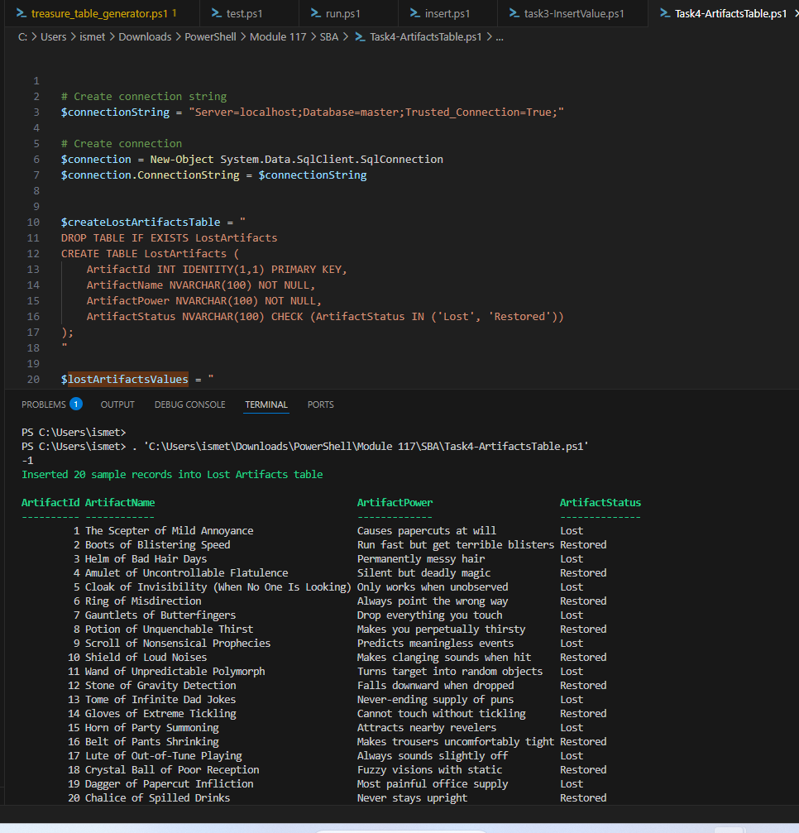

Only lost:
# Create connection string
$connectionString = "Server=localhost;Database=master;Trusted_Connection=True;"

# Create connection
$connection = New-Object System.Data.SqlClient.SqlConnection
$connection.ConnectionString = $connectionString

# Define SQL to create table
$createLostArtifactsTable = "
DROP TABLE IF EXISTS LostArtifacts;

CREATE TABLE LostArtifacts (
ArtifactId INT IDENTITY(1,1) PRIMARY KEY,
ArtifactName NVARCHAR(100) NOT NULL,
ArtifactPower NVARCHAR(100) NOT NULL,
ArtifactStatus NVARCHAR(100) CHECK (ArtifactStatus IN ('Lost', 'Restored'))
);
"
# Define SQL to insert sample data
$lostArtifactsValues = "
INSERT INTO LostArtifacts (ArtifactName, ArtifactPower, ArtifactStatus) VALUES
('The Scepter of Mild Annoyance', 'Causes papercuts at will', 'Lost'),
('Boots of Blistering Speed', 'Run fast but get terrible blisters', 'Restored'),
('Helm of Bad Hair Days', 'Permanently messy hair', 'Lost'),
('Amulet of Uncontrollable Flatulence', 'Silent but deadly magic', 'Restored'),
('Cloak of Invisibility (When No One Is Looking)', 'Only works when unobserved', 'Lost'),
('Ring of Misdirection', 'Always point the wrong way', 'Restored'),
('Gauntlets of Butterfingers', 'Drop everything you touch', 'Lost'),
('Potion of Unquenchable Thirst', 'Makes you perpetually thirsty', 'Restored'),
('Scroll of Nonsensical Prophecies', 'Predicts meaningless events', 'Lost'),
('Shield of Loud Noises', 'Makes clanging sounds when hit', 'Restored'),
('Wand of Unpredictable Polymorph', 'Turns target into random objects', 'Lost'),
('Stone of Gravity Detection', 'Falls downward when dropped', 'Restored'),
('Tome of Infinite Dad Jokes', 'Never-ending supply of puns', 'Lost'),
('Gloves of Extreme Tickling', 'Cannot touch without tickling', 'Restored'),
('Horn of Party Summoning', 'Attracts nearby revelers', 'Lost'),
('Belt of Pants Shrinking', 'Makes trousers uncomfortably tight', 'Restored'),
('Lute of Out-of-Tune Playing', 'Always sounds slightly off', 'Lost'),
('Crystal Ball of Poor Reception', 'Fuzzy visions with static', 'Restored'),
('Dagger of Papercut Infliction', 'Most painful office supply', 'Lost'),
('Chalice of Spilled Drinks', 'Never stays upright', 'Restored');
"

try {
# Open the connection
$connection.Open()

# Execute table creation
$command = $connection.CreateCommand()
$command.CommandText = $createLostArtifactsTable
$command.ExecuteNonQuery()

# Insert sample data
$command.CommandText = $lostArtifactsValues
$rowsInserted = $command.ExecuteNonQuery()
Write-Host "Inserted $rowsInserted sample records into LostArtifacts table" -ForegroundColor Green

# Query only the 'Lost' artifacts
$command.CommandText = "SELECT * FROM LostArtifacts WHERE ArtifactStatus = 'Lost'"
$adapter = New-Object System.Data.SqlClient.SqlDataAdapter $command
$dataset = New-Object System.Data.DataSet
$adapter.Fill($dataset) | Out-Null

# Display results in a formatted table
$dataset.Tables[0] | Format-Table -AutoSize
}
catch {
Write-Host "Error: $_" -ForegroundColor Red
}
finally {
# Close connection if open
if ($connection.State -eq 'Open') {
$connection.Close()
}
}

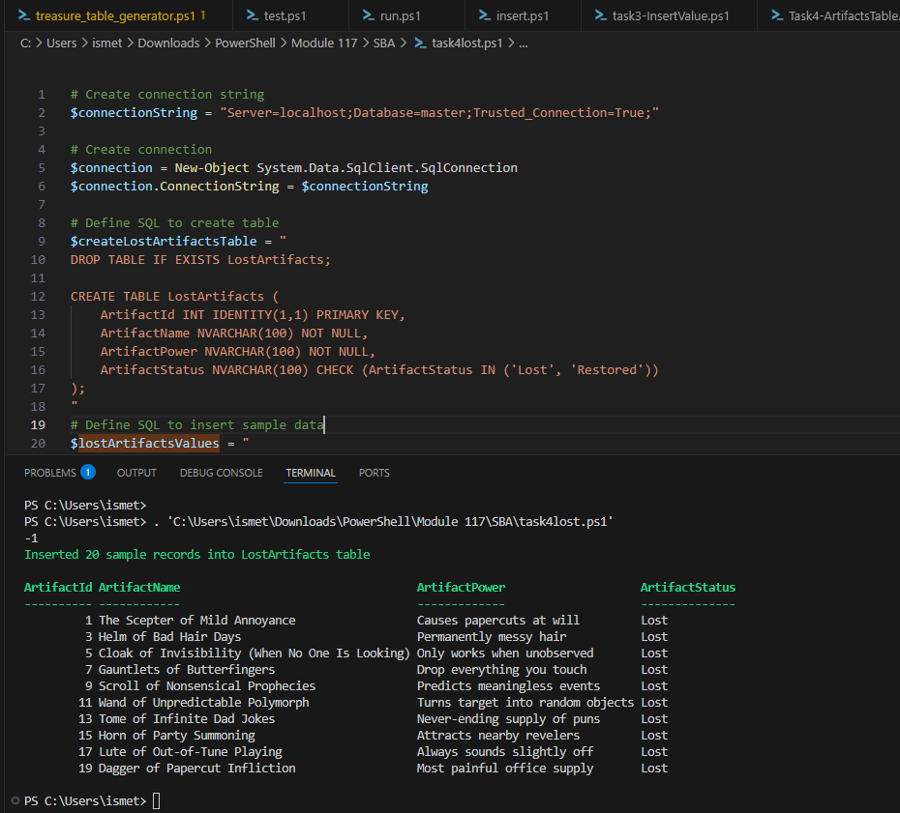

Chapter 5: The Scroll of Restoration
Task 5: The Grand Restoration
The final task is for you to use PowerShell to restore the lost relics and bring them back to life. Execute a script to update the status of artifacts in the "LostArtifacts" table, and mark them as "Restored."

Powershell
# Example PowerShell script to restore lost artifacts in the database
# Create connection string
$connectionString = "Server=localhost;Database=master;Trusted_Connection=True;"

# Create connection
$connection = New-Object System.Data.SqlClient.SqlConnection
$connection.ConnectionString = $connectionString

# Define SQL to update artifact status
$updateArtifactStatus = "
UPDATE LostArtifacts
SET ArtifactStatus = 'Restored' -- Update the ArtifactStatus to 'Restored'
WHERE ArtifactStatus = 'Lost'; -- Condition: only for those artifacts marked as 'Lost'
"

try {
# Open the connection to the database
$connection.Open()

# Execute the update command to restore all 'Lost' artifacts
$command = $connection.CreateCommand()
$command.CommandText = $updateArtifactStatus # Use the update query to restore artifacts
$rowsUpdated = $command.ExecuteNonQuery() # Executes the query and returns the number of rows affected
Write-Host "Restored $rowsUpdated lost artifacts to 'Restored' status" -ForegroundColor Green

# Query to verify the artifacts with their new status
$command.CommandText = "SELECT * FROM LostArtifacts WHERE ArtifactStatus = 'Restored'"
$adapter = New-Object System.Data.SqlClient.SqlDataAdapter $command
$dataset = New-Object System.Data.DataSet
$adapter.Fill($dataset) | Out-Null

# Display results in a formatted table
$dataset.Tables[0] | Format-Table -AutoSize
}
catch {
# Error handling
Write-Host "Error: $_" -ForegroundColor Red
}
finally {
# Close the connection if it's still open
if ($connection.State -eq 'Open') {
$connection.Close()
}
}

